CELEBREMOS

Software Requirements Specification

Version 3.0

06/13/2019

Hari Priya Jupally

Karun Bourishetty

Indra Reddy Mamidi

Vishal Reddy Pannala

Saikumar Nalivela

Poojitha Singam

Sai Ram Badisa

Submitted in partial fulfilment

Of the requirements of

CSIS 44-691 Graduate Directed Project 1

**Revision History**

|  |  |  |  |
| --- | --- | --- | --- |
| **Date** | **Description** | **Author** | **Comments** |
| 06/11/2019 | Version 1.0 | Poojitha Singam | Initial gathering of requirements by understanding the evite website. |
| 06/12/2019 | Version 2.0 | Hari Priya Jupally | Updated requirements and ER diagram. |
| 06/13/2019 | Version 3.0 | Indra Reddy | Created prototype |
|  |  |  |  |

# **Document Approval**

The following Software Requirements Specification has been accepted and approved by the following:

|  |  |  |  |
| --- | --- | --- | --- |
| **Signature** | **Printed Name** | **Title** | **Date** |
|  |  |  |  |
|  |  |  |  |
|  |  |  |  |

**Table of Contents**

**Table of Contents Page Number**

1.Introduction

1.1.Purpose

1.2.Scope

1.3.Definitions, Acronyms, and Abbreviations

1.4.References

1.5.Overview

2.General Description

2.1.Product Perspective

2.2.Product Functions

2.3.User Characteristics

2.4.General Constraints

2.5.Assumptions and Dependencies

3.Specific Requirements

3.1.External Interface Requirements

3.1.1.User Interfaces

3.1.2.Hardware Interfaces

3.1.3.Software Interfaces

3.1.4.Communications Interface

3.2. Functional Requirements

3.3. Use Cases

3.4. Class/Objects

3.5. Non-Functional Requirements

3.5.1. Performance

3.5.2. Reliability

3.5.3. Availability

3.5.4. Security

3.5.5. Portability

3.6. Inverse Requirements

3.7. Design Constraints

3.8. Logical Database Requirements

3.9. Other Requirements

3.10. Prototypes (for complete project)

3.11. Use Case Diagrams

4. Design

4.1. ER diagram

4.2. GUI

5.Analysis Models

5.1. Data Flow Diagram

5.2. Sequence Diagram

## 

1. **Introduction**

**1.1 Purpose**

The main purpose of application is to create, modify and delete online invitation system which helps the people to invite guests for their party to manage the number of people attending the event, creating polls to finalize food menu and what costume they have to wear. This application helps the event organizers to plan the event successfully without any issues.

**1.2 Scope**

The scope of the project is to create an application that helps the event organizers to invite the guests to party which helps the organizers to plan for the place, food items, number of guests, what are the lists of items they need to bring while coming to the party and what costume they have to wear.

**1.3 Definitions, Acronyms, and Abbreviations**

RSVP - Répondez s'il vous plaît (Please respond)

**1.4.References**

**1.5.Overview**

**2.General Description**

**2.1.Product Perspective**

**2.2.Product Functions**

**2.3.User Characteristics**

**2.4.General Constraints**

**2.5.Assumptions and Dependencies**

**3.Specific Requirements**

**3.1.External Interface Requirements**

**3.1.1.User Interfaces**

**3.1.2.Hardware Interfaces**

**3.1.3.Software Interfaces**

**3.1.4.Communications Interface**

1. Google Docs
2. Whats App
3. Gmail

**3.2. Functional Requirements**

1. Create Home page
2. Create the Login page  
   A. Create the register page  
   B. Create sign-in page  
   C. Managing forgot password.
3. Creating profile page
4. Creating the events page.
5. Create invitation template  
   A. Create templates for birthday.  
   B Create templates for marriage.  
   C. Create templates for graduation.
6. Create details page of template  
   A. Modifying the details of template  
   B. Customizing the RSVP style (Please respond)
7. Creating the guest list for sending the invitation.  
   A. Send mail through mail-id  
   B. Send text message through phone number
8. Managing the event page  
   A. Create the details tab  
   B. Create messaging tab  
   C. Create managing guest tab  
   D. Creating what to bring tab  
   E. Creating polls  
   F. Setting tab

**3.3. Use Cases**

**3.4. Class/Objects**

**3.5. Non-Functional Requirements**

**3.5.1. Performance**

**3.5.2. Reliability**

**3.5.3. Availability**

**3.5.4. Security**

**3.5.5. Portability**

**3.6. Inverse Requirements**

**3.7. Design Constraints**

**3.8. Logical Database Requirements**

**3.9. Other Requirements**

**3.10. Prototypes (for complete project)**

**Login Page:**

**Registration**

**Event Dashboard**

**Event details**

**Cards Page**

**Manage Dashboard**

**Profile Page:**

**3.11. Use Case Diagrams**

**4. Design**

**4.1. ER diagram**

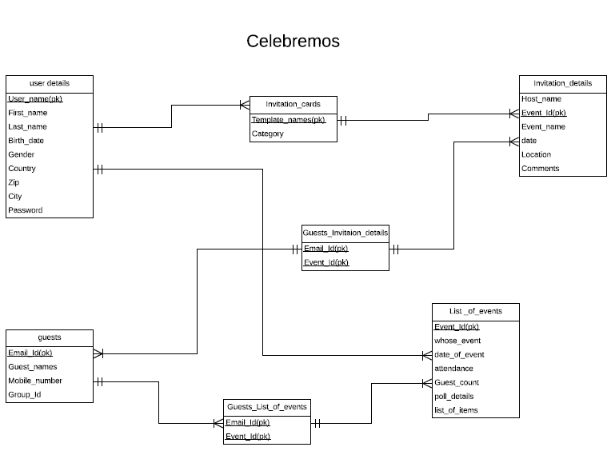

The above ER diagram has 6 entities and 1 associative entity. A user can see some Invitation cards and use an invitation card to send invitation. User can add any number of guests and see all the events he has hosted or invited to. He can manage events and RSVPs.

**4.2. GUI**

**5.Analysis Models**

**5.1. Data Flow Diagram**

**5.2. Sequence Diagram**